A Letter from St. James

Mill Creek Hundred

October 2012

***RECTOR’S RAMBLINGS . . . . .*** *Putting First things First*

September has come and gone and we are off to a great start to the Fall. The choir is back in full swing and classes have started in our Sunday Morning Academy for Children and Adults. We had a lot of fun with our Welcome Back Rodeo in the church parking lot, and followed that up with a visit to the Cowtown Rodeo in southern New Jersey. We even took along six guests of the Family Promise network for a night out. As I said on a recent Sunday, we as Christians can at times take ourselves too seriously and risk overlooking the grace that God provides when we learn to play together. Fellowship is the bedrock of strong relationships, and relationships are what give meaning and value to life.

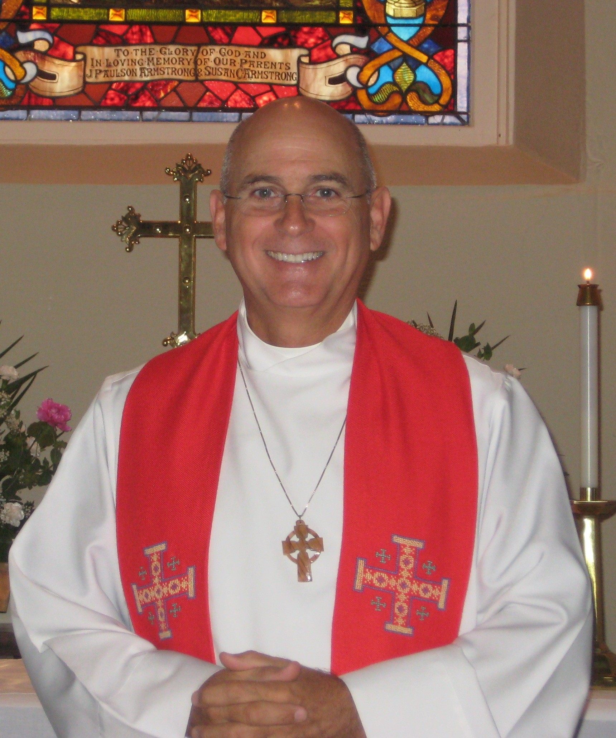

Now that it’s October the women of the Craft Workshop are busily putting the final touches on the items that will be up for sale at the annual Bazaar (to be held November 2nd and 3rd), and others members of the parish are working on lining up donations and volunteers for the big Turkey Dinner. In addition, the Tercentennial Committee is continuing its planning and organizing for the start of our observance of the 300 year history of St. James’. Very soon the Worship Life Ministry Team, Flower Committee and Altar Guild will begin their planning for Christmas services and beyond. And add to all of this the new Tuesday evening Bible study that my wife and I are offering in our home.

Amidst all these activities and more we must not, however, lose sight of what we are about as followers of Jesus Christ. Yes, we may be busy with all of the things we take on; at times we will certainly become weary; but we must never put aside our first duty as Christians which to give our lives to God in worship and prayer. For those who are physically able, regular attendance at church services should be the starting point of our witness to the redeeming love of God. It is that witness to each other and to the community around us that is the measure of our offering and commitment to Christ.

There is always much that we find important to be doing. Attending first to our spiritual needs and health should be at the top of the list.

- Fr. Jim Bimbi

**altar4c.tifALTAR GUILD TRAINING**

 We will be having Altar Guild training during October.  This is for new members and for anyone interested in finding out more about the Altar Guild.  If you would like to join us, please see or call Debby Nuss.

**Kathy Kwiatkowski and Barbara Anzilotti are our turkey dinner co-chairs this year!**

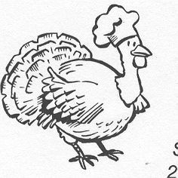

Get Your Gobble on - Get Ready for the Turkey Dinner - Saturday November 3.  Come to eat, come to volunteer, come for both.  Three seatings (3PM, 5PM and 6:30 PM) and take out.  Get your tickets after service or at the office.  Call 994-1584 or office hours are.....  Have fun and help.  Signup sheets are in the parish hall to donate food stuff, slice pies, cook and/or carve turkeys, serve tables, wash and dry, clean up. 

## ST. JAMES’ 2012 ANNUAL BAZAAR

**Friday, November 2nd 10:00 AM – 3:00 PM**

**Saturday, November 3rd 10:00 AM – 7:00 PM**

The Bazaar Ladies have worked hard all year creating many new hand crafted items, beautiful wreaths and arrangements for the 2012 Bazaar.

Be sure to come out one or both days to shop for that special something in our Bazaar Shops, buy chances for this year’s beautiful quilt and stop by the Bake Shop for a great variety of goodies.

***Quilt Raffle***

The St. James Quilters have created another beautiful hand stitched quilt with two small matching throw pillows. The quilt will be on display in the Parish House each Sunday from October 7th through October 28th after both services. Chances will be available at those times**. The chances are $1.00 each, 6/$5.00 or 15/$10.00.**

***Sunday, October 28th, Your Help Is Needed***

Sunday, October 28th, after the 10:15 service, we will be moving all of the craft items from the Bazaar Room to the various Bazaar Shops. We need your help bringing these items upstairs. This is also a good opportunity to get a peek at the things we have made for the Bazaar.  ***See******you October 28th…***

# *The Bake Shop*

# **The Bazaar Bake Shop is looking forward to your donations of baked goods, candy, preserves and various homemade mixes. We are counting on you to make this year another success. Your delicious donations are the reason the Bake Shop always sells out of everything.** *Thank You!!!!!!!!*

***You may drop off your homemade items at the Parish House at the following times:***

**Thursday, November 1st: 5:30pm to 8:00p m -**

**Friday, November 2nd: 8:00am – 2:30pm**

**Saturday, November 3rd: 8:00am – 12:00pm**

***Bazaar Preview***

# **Prior to the Bazaar some of the items will be on display in the Parish House. They are in the glass case in the foyer. We hope you will have time to stop by and see them. The ladies have been very creative again this year.**

# ***Surprise Visitor***

**A “*Jolly Visitor*” will be stopping by the Bazaar Saturday, November 3rd. Please bring your children and grandchildren so they can spend some time with him. Watch your weekly Bulletin and e-Epistle for additional details.**

# **BAZAAR SHOPS**

## *Something for Everyone*

**Bring your friends & family members for a day of shopping and good food**.

***Christmas Shop* -** Everything you need for the holiday: ornaments, wreaths, wall hangings, decorations, snowmen, angels, etc.

***Petal Alley*** -Beautiful arrangements & wreaths; we have seasonal pieces and new decorative items.

***One Fine Yarn*** *-*The best handmade items you will find anywhere. The ladies have been busy quilting, knitting, crocheting and sewing.

***Craftily Yours* -** This is the perfect shop for that special gift. The selection includes gift baskets, cross-stitch, many new hand crafted jewelry items, and much more.

***ABC*** - You will find everything for the children; knitted and crocheted afghans, sweaters and hats. There are books and stuffed animals too.

***The Bake Shop*** - We have everything for the sweet tooth: Pies, cakes, cookies, breads, preserves, and candy. This is the tastiest corner of the Bazaar.

***The Raffle Table*** -You will be pleased with the items we have this year. Don’t forget to stop at the Raffle Table in the hallway.

***St. James Cookbook***

*The St. James Cookbook will be on sale again this year. It is a great gift.*

***The St. James’ Tercentennial Crock***

*The Tercentennial Crock will be on sale also at this year’s Bazaar. It is made by local pottery artist, Maggie Creshkoff. The crock is made from local clay. Each one is individually hand thrown, hand stamped and drawn upon, lettered and glazed.*

***Bazaar Luncheon***

**The Luncheon will be Friday, November 2nd, from 11AM to 1PM. Come shop and enjoy a delicious lunch prepared by Sam White and Fr. Jim.**

***Turkey Dinner***

The Turkey Dinner will be Saturday, November 3rd. There will be three seatings and tickets go on sale Sunday, October 7th. Times are 3:30 PM; 5:00 PM and 6:30 PM with take-out available.

All take out dinners are $12. For dining in our dining room, ticket prices are: Adult - $12;

Seniors (65 and up) $10; Children (5-10) $6.

*There are several opportunities for you to contribute to the success of your Bazaar, Luncheon, and Turkey Dinner*

*Sign-Up sheets are posted in the Great Hall in the Parish House.*

PLEASE SIGN UP TO HELP

Help is needed setting up for Friday’s Luncheon and Saturday’s Turkey Dinner.

Kitchen helpers and servers are needed for the Luncheon and the Turkey Dinner.

Relief workers are needed in all the shops during the Luncheon and Turkey Dinner.

Food donations for the Turkey Dinner and turkey cookers are needed.

Desserts for the Luncheon are also needed.

Saturday evening we need help cleaning up and getting the classrooms ready for Sunday.

This is a wonderful opportunity to support your church and spend time with family and friends. All of us working together will make this a successful event.

***LOOKING FORWARD TO SEEING YOU NOVEMBER 2ND AND 3RD.***

***THANK YOU FOR YOUR SUPPORT!***

***calen5.tifSave the Date:***   Tho we have not even had Halloween, Thanksgiving and Christmas yet... still I want you to put something on your calendar that is coming up for LENT!!!   A Lenten Retreat at Memorial House in Rehoboth Beach is scheduled for ***February 22-24, 2013.***  The theme is **"Know Chocolate for Lent".** The retreat will be led by Sister BJ and Sister Julian.  More details as the date draws closer.

**Tuesday, October 9, 2012,** **The Tercentennial Planning Group** will be meeting in the Great Hall of the Parish House at 7:00, PM. Everyone is welcome to attend.

**The Highlands Chamber Players present an Evening of Musical Favorites**

**Sunday, October 21, 2012, 7 pm**

**St. James Mill Creek Episcopal Church,**

**2106 Saint James Church Road**

Including music by Arne, Buxtehude, Handel, Vaughan Williams, and Vivaldi

A freewill donation will be collected to benefit outreach programs.

**Classes for Confirmation and Reception as Members**

**CONFIRMATION**

In our Christian tradition, Confirmation is a sacramental affirmation of a mature commitment to Christ. What does this mean? It means that a person is ready to more fully claim and live the faith conveyed at baptism. Many Christians were baptized as infants or young children. The period of study in preparation for confirmation is meant to guide them towards an adult commitment to Christ. Confirmation is not limited to young persons, however, and can also play a part in the maturing involvement of Christians of any age. There is no minimum age for confirmation, although as a general rule children should be at least 12-13 years old. After a time of preparation the confirmands gather in worship to receive strength from the Holy Spirit through prayer and the laying on of hands by a bishop.

**RECEPTION**

Reception is the formal way in which we receive into the Episcopal Church those who have made a mature commitment to Christ while a member of another Christian denomination. Generally this refers to people who have been confirmed while a member of the Roman Catholic or Lutheran churches, although acts of commitments in other denominations may also be acknowledged. The rite of reception is administered by a bishop and takes place within a worship service, typically at the same time as confirmations.

**CLASSES and BISHOP’S visit**

Please contact Fr. Bimbi as soon as possible if you are interested in these classes. The day and time of the classes will be set to best accommodate those who are interested. The Confirmation and Reception service with Bishop Wright will be held at our church on January 13, 2013.

**Family Promise**

**Building Community, Strengthening Lives**

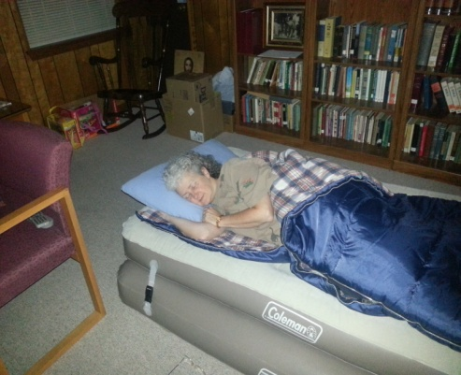We at St. James’ have completed another successful host week for Family Promise. In keeping with our Family Promise ministry, we served four families currently in the network. These families were a delight to host and exceptionally grateful for our hospitality. They enjoyed the wonderfully prepared meals with gusto! These home-cooked meals really won them over! We want to thank **everyone** who helped.

Thanks to an anonymous donation, we were able to treat the families to a night out at the Cowtown Rodeo, in New Jersey. They thoroughly enjoyed themselves despite the long lines for the funnel cakes and the cool temperatures. Perhaps you have an idea for an outing during our next host week?

We are always looking for volunteers to help with this ministry. For those who enjoy cooking, you may want to prepare one of the evening meals. To make this less daunting, we can coordinate schedules to have two or more families share the responsibility for one of the meals. Perhaps you would rather shop for groceries; the families prepare their own breakfasts and lunches with the items that you buy. Valerie Bragg can provide you a list of items that are needed. One of the most fulfilling ways to help is to volunteer to be one of the overnight hosts. You are welcome to share the evening meal with the families that prepared it and our Family Promise guests. Conversations over dinner are always fascinating and the fellowship is rewarding. There’s always time for some quiet reading. If you would like to bring your laptop computer, you are welcome to connect to the church’s wireless network. When you arise, you brew coffee and boil water for tea. The guests awake on their own. You are welcome to make breakfast for yourself. By 7:00 A.M., all of the guests have left and you are free to go…very easy!

Volunteer Eileen Marvel, Overnight Host.

Our next host week runs from Sunday, December 16, 2012, through Sunday, December 23, 2012. Please mark your calendars and get involved during this special time of the year. We are blessed to host them during this holiday season. Hope to see you then! For more information, just ask Jennifer Idell, Susan Winward, Dave Perry or Valerie Bragg.

Feel the warmth of Family Promise — volunteer.

*-Jen Idell*

**REGISTER NOW!**  **Parish Life Day** to be held, Saturday, November 17th, St. Anne’s School from 8:30 am to 3:15 p.m. Your $20 registration fee includes a continental breakfast and your lunch. There is a free program for young children.  A **new** flavor for Parish Life Day 2012 will be interactive workshops, which has generated the theme for this year – ‘Hands-On Works’.   Each workshop presented will include a hands-on approach.  **Parker Kitterman** will be the ‘headliner’ this year, providing the music and liturgy for both worship sessions and facilitating two workshops, Making the Square Circle.

Join Episcopalians from around the diocese for a day of worship, education & fellowship.

**MORNING WORKSHOPS**

* Poetry Writing: Poet Maggie Rowe is back by popular demand!
* Digital Evangelism: Introduction to integrating your website and social media to tell your faith stories
* Making the Square Circle: How we can work the shape-note singing tradition into our own worship music
* Tai Chi
* Spanish as a Second Language/Pastoral
* Beating the Beads . . . Praying with our hands as well as our hearts - while learning how to tie knotted Anglican rosaries
* Centering Prayer- - Hands on!
* Storytelling for Preaching, Teaching, and Pastoral Care

**AFTERNOON WORKSHOPS**

* "LET"TUCE explore and "FIG"URE out how to make half my plate fruits and veggies
* Water Color Art
* Art of “Divine Flower Arrangements” for your church
* Bible Study - explore images and phrases that help us live out our faith in a ‘hands-on’ way
* Digital Evangelism: Introduction to integrating your website and social media to tell your faith stories
* Making the Square Circle: How we can work the shape-note singing tradition into our own worship music
* Centering Prayer- - Hands on!
* ECW - Delaware Annual Meeting: *All who plan to attend this meeting will need to complete the Parish Life Day registration*

To register and view more workshop details, event information, and brochure go to [www.dioceseofdelaware.net](http://dioceseofdelaware.us1.list-manage.com/track/click?u=276bc6d856ba3637118988905&id=ffa59b021f&e=6140fb1874) and click on Parish Life Day.  If you have any questions, please contact Genia in the church office or pick up a brochure in the church or Parish Hall.

**ST. JAMES CHURCH MILL CREEK**

**VESTRY MEETING MINUTES**

September 10, 2012

**PRESENT:** Fr. James Bimbi, Bruce Vrana, Sister B. J. Brown, Olivia Jessup, Ann Kauffman, Kathy Kwiatkowski, Debbie Nuss, Bob Meckelnburg, Steve Prescott, Gail Zimmerman, Nancy Patterson

**ABSENT:** Carolyn Joynt

The regularly scheduled meeting of the Vestry of St. James Church Mill Creek was called to order at 7:20pm. Fr. Jim led the Vestry in an opening prayer.

**MINUTES OF PREVIOUS MEETING:** Approved

**UNFINISHED BUSINESS:**

**Thank You Notes –** The following Thank You notes will be sent:

* Marlene and Kathy Jackson for all their hard work in the cemetery
* Cynde Bimbi for organizing and planning the Welcome Back Rodeo
* Jerry Clark for cooking and preparing the food served at the Rodeo
* Jim Burns for getting the hay for the Rodeo

**Civil Unions –** Civil Unions will be discussed at the Vestry Retreat

**Family Promise –** The Rectory has been inspected and everything was in order. The contract will be finalized within the next month.

**Vestry Retreat –** The Retreat will be held Saturday, October 6th from 8:30 – 3:00.

Topics to be discussed are: Civil Unions, Fiscal Issues and Stewardship

**Tercentennial –** Fr. Jim met with the Wardens to discuss the Tercentennial Budget.

The funds to be budgeted are from donations designated for the Tercentennial, proceeds from the Quilt Stars and the sale of the St. James Crocks. Approximately $3600 has been donated toward expenses. From that we need to set aside the amount needed to host the 2014 Diocesan Convention (a commitment made several years ago). The Tercentennial Committee has yet to make any specific requests for funds. After some discussion the $3,600 in donated funds were designated as follows:

***$1,000 for hosting 2014 Diocesan Convention***

***$1,000 for music/worship events***

***$ 800 for publicity***

***$ 800 available for allocation upon receipt of specific proposals***

The following motion regarding Tercentennial activities was seconded and approved:

***Once funds are approved by the Vestry for specific activities, the designated subcommittee chair or project leader may expend funds up to the budgeted amount. All requests for allocation or reimbursement will be made through the Rector or Senior Warden.***

In order to reiterate the existing policy on fundraising activities, the Vestry approved the following statement:

***There are presently two fundraisers being conducted in connection with the Tercentennial of St. James Church: the sale of “stars” on a commemorative quilt, and the sale of commemorative crocks. In line with long-standing policy of the Vestry on fundraisers within the parish, no further fundraisers for any Tercentennial project, or any project related to St. James’ church, are to be undertaken without prior approval of the Vestry.***

**Capital Campaign -** Tobe discussed at the Retreat.

**TREASURER’S REPORT:** Steve Prescott and the Financial Advisory Committee are reviewing all financial issues.

**NEW BUSINESS:** No New Business

**VESTRY GREETER REPORTS:**

8:00 – Nothing new to report

9:30 – One New Family

**RECTOR’S REPORT:**

Fr. Jim has been invited to attend an 8-day CREDO II Conference (Clergy Reflection, Education, Discernment Opportunity) to be held in Richmond, VA in June 2013.

Sister B.J. Brown was asked to lead a Women’s Retreat for Lent, February 22nd – 24th at Memorial House. She requested $500 for the deposit to reserve Memorial House. The $500 will be returned once those attending the Retreat pay their Registration Fee.

Fr. Jim will be visiting his children and grandchild next week. The Rev. Gary Taylor will be the clergy on September 23rd. He is the chaplain at St. Ann’s School.

Good Shepherd Episcopal Church will have its last service Sunday, September 16th.

**COMMITTEE REPORTS:**

**WORSHIP:** Committee did not meet. The Choir is back.

**PROPERTY:** Committee did not meet.

**FINANCE:** We still need someone to take over the duties of Treasurer

**PARISH LIFE:**  Kathy Kwiatkowski volunteered to Co-Chair the Turkey Dinner and Barbara Anzilotti offered to help Kathy.

**TERCENTENNIAL/HISTORY:** Already discussed.

**MISSSION/OUTREACH/FAMILY PROMISE:** St. James will host Family Promise the week of September 23rd. We still need volunteers**.**

**EDUCATION:** The Opening Day Welcome Back Rodeo was a big success. Everyone had a lot of fun.

Adult classes will be offered starting Sunday, September 16th.

Fr. Jim is planning to offer Bible Study Classes to be held Tuesday evenings.

**SENIOR WARDEN’S REPORT:**

Bruce Vrana will be away next week.

The next Vestry Meeting will be held during the Vestry Retreat.

**DIOCESAN CONVENTION:**

The 2013 Convention will held February 1st & 2nd at the Sheridan Hotel in Dover.

St. James will have 2 delegates and 2 alternates. Now is the time to consider any ideas you may have about putting forth a resolution. Fr. Jim has been thinking about a resolution that would increase the involvement of youth.

There being no further business, the Vestry meeting concluded at 8:50pm with a moment of silence and The Lord’s Prayer

Respectfully Submitted,

Nancy Patterson

Clerk of the Vestry

**October Anniversaries**

3rd Perrie and Bob Carrow

Kate & Bob Hoppenjans

8th Elizabeth & Kurt Lichtenstein

10th Mary Burns & John Bryans

Amy & John Taylor

12th Karen & George Shogan

Bob & Laura Sheppard

17th Elva & Barry Coverdale

19th Christine & Robert Haywood

26th Annmarie & Shawn Patterson

30th Jennifer & Darren Cormier

**October Birthdays**

1st Robert Vrana

2nd Barbara Gove

Craig Galante

Marsha Cauthen Wilson

3rd Jennifer Cormier

4th Brian Sheppard

7th Barbara Seddon

Ava Loveless

Faith Page

8th Gail Coverdale

9th Samuel Manthorpe

10th Laura Sheppard

12th Aaron Moyer

Connor Deibert

16th Douglas Marvel

Richard Aichele

17th Amy Burns

18th Stephen Tuhy

19th Madelyn Sandlhauser

Beth Remedio

20th Elva Coverdale

22nd Alexander Galante

23rd Trevor Dennis

Alan Cascino

24th The Rev. Lee Brownell

27th Paul Pomeroy

Irene Deibert

28th Lee Jessup

Billy Jennings

**Happy Birthday to all!**

*If we missed your birthday or anniversary, please call the office and let us know. You are an important member of our parish family.*



**Family Promise Fund Raiser**:  Family Promise Fund Raiser:  For your donation of just $5.00 you will receive a 25% off coupon good at Boscov's on October 16, 2012.  The entire donation will go toward supporting Family Promise of Northern New Castle County DE.  See Susan Winward for details.

Bring your pets to church on Sunday,

October 7th. As long as they can be controlled and get along well with others, they are welcome to come to the service to be blessed.

Children can also bring stuffed animals if they wish to be blessed. Can’t bring your pet? Bring a picture and it will still be blessed

Blessing of the Animals

October 7, 2012

**Thank YOU for your generosity**

Lynne Baker received a thank you letter from Delaware Health and Social Services. It says in part: “thank you for your generous gift of $1,385.00 to support our Adopt-A- Student program this year… The Adopt-A-Student provides backpacks, new school supplies and gift cards for uniforms to children in need. The goal of this program is to encourage a positive attitude toward school by helping each student start the school year with the necessary supplies to achieve success;…The 2012 Adopt-A-Family has been able to help 1,752 people.”

Saint James goes to the Rodeo

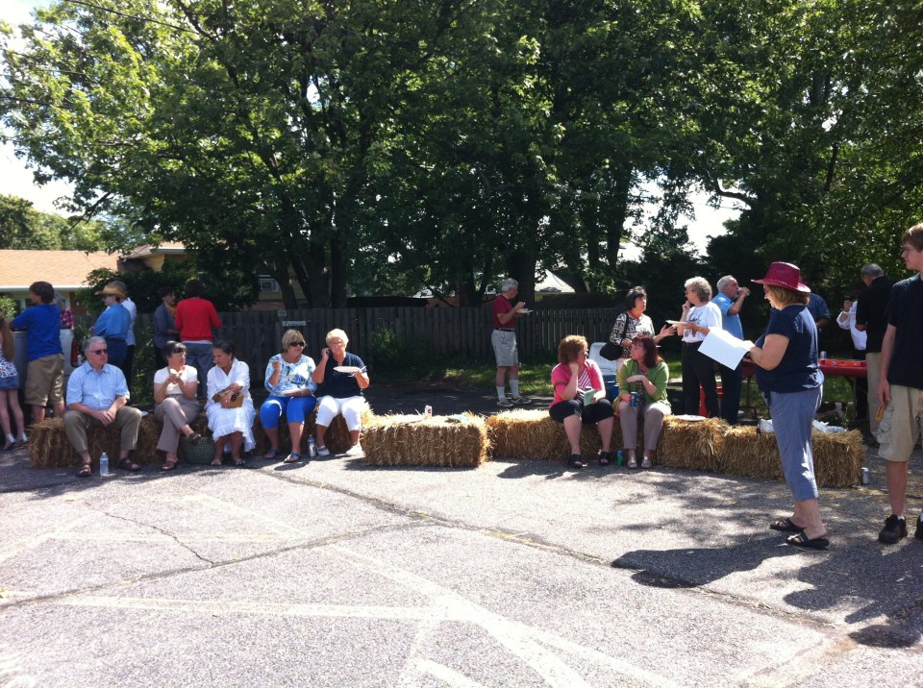On September 9th we began our Christian Education program with a rodeo and BBQ in our parking lot.

With great food, fun games and great fellowship. A good time was had by all.

What a great way to kick off our fall programs!

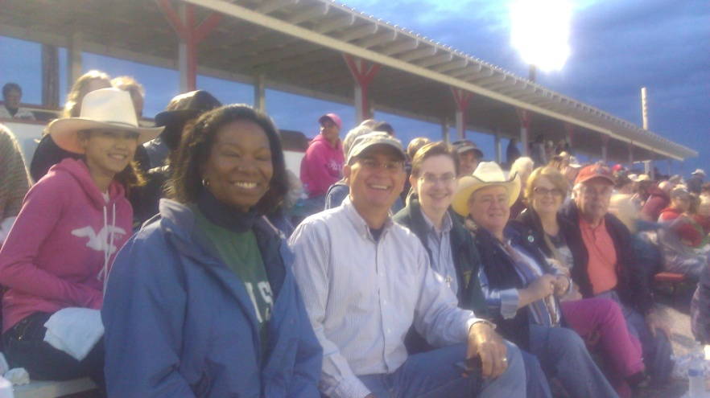Be sure to join us in future activities! It’s funa dn a grat way to get to know fellow parishioners better,

Then, on September 29th, we went to the real Rodeo at Cowtown. We took six members of the Family Promise group we were hosting and everyone had a wonderful time.

Our thanks to those who organized thesefun events for us.

**A Letter from St. James**

**October 2012**

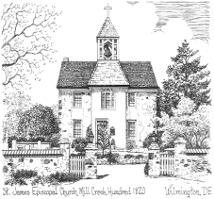

Non-Profit Organization

U.S. Postage Paid

Permit # 36

Wilmington, DE

St. James’ Episcopal Church

2106 St. James’ Church Road

Wilmington, DE 19808

Address Service Requested

   



    

Rector: The Rev. James M. Bimbi

Senior Warden: Bruce Vrana

Junior Warden: Carolyn Joynt

Office Contacts

Phone: 302-994-1584 / Fax: 302-994-3778

Email: office@stjamesmillcreek.comcastbiz.net

Website: stjamesmillcreek.org

Office Hours: 9:00 a.m. – 2 p.m.

Tuesday – Thursday

Closed Monday and Friday

**Service Times**

**Sunday-**

8:00 AM Holy Eucharist

9:15 AM Christian Education for all ages

10:15 AM Family Choral Eucharist

**Wednesday**

10:00 AM Eucharist & Healing Service

6:15 PM Evening Prayer Service

pets1c.tif

**OCTOBER 7, 2012**

**Bring your pet to church to be blessed**

**BazaAR ANNUAL.tif**

**ANNUAL BAZAAR**

**& TURKEY DINNER**

**Bazaar – November 2 & 3rd**

**Bazaar Luncheon November 2nd**

**turkey dinner.tif Turkey Dinner November 3rd**