
Saint James’ Episcopal Church
November 2012
Sunday | Monday | Tuesday | Wednesday | Thursday | Friday | Saturday
 |  |  |  | 1  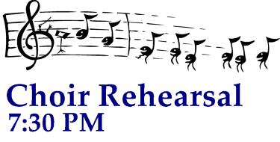 | 2  Bazaar  10 AM – 3 PM  Luncheon  11Am – 1 PM  Office Closed | 3  Bazaar  10AM – 7 PM  Turkey Dinner  3:30, 5:00 & 6:30 PM
4  All Saints’ Day  8:00 a.m. HolyEucharist  9:00 a.m. SMACA  10:15 a.m. Holy Eucharist  With Infant Baptism  11:30 a.m. Coffee Hour | 5    9AM Bazaar Wrap-UP  7PM  office closed | 6  ELECTION – Polling Place    Bible Study at the Bimbi’s 7 PM | 7  Holy Eucharist  and Healing Service  10:00 am  Evening Prayer 6:15 PM | 8 | 9  Office Closed | 10
11  8:00 a.m. HolyEucharist  9:00 a.m. SMACA  10:15 a.m. Holy Eucharist  11:30 a.m. Coffee Hour | 12  Vestry -Lounge 7:15 PM   | 13  Bible Study at the Bimbi’s 7 PM | 14  Holy Eucharist  and Healing Service  10:00 am  Evening Prayer 6:15 PM | 15 | 16  Office Closed | 17
18  8:00 a.m. HolyEucharist  9:00 a.m. Celebration  Brunch  10:15 a.m. Holy Eucharist  11:30 a.m. Coffee Hour | 19    1 PM - Lounge  office closed | 20  Bible Study at the Bimbi’s 7 PM | 21  Holy Eucharist  and Healing Service  10:00 am  Ecumenical Community  Thanksgiving Service @  St. Mark’s UMC- 7PM  1700 Limestone Road | 22  9 AM Worship Service | 23  Office Closed | 24
25  8:00 a.m. HolyEucharist  9:00 a.m. SMACA  10:15 a.m. Holy Eucharist  11:30 a.m. Coffee Hour  11:30 a.m. Parish Life Committee - Lounge | 26  office closed | 27 | 28 Holy Eucharist  and Healing Service  10:00 am  Evening Prayer 6:15 PM | 29 | 30  Office Closed

